**Case Study 1**

1. How are the daily returns of NASDAQ distributed? Does it follow a normal  
   distribution?

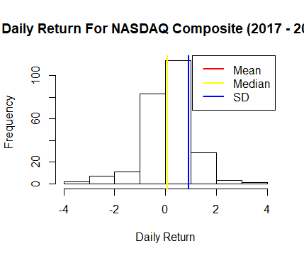

**Based on the graph above, the daily return is normally distributed (the distribution is approximately symmetrical).**

1. Are any obvious trends visible in movement of NASDAQ prices for the  
   period under study?

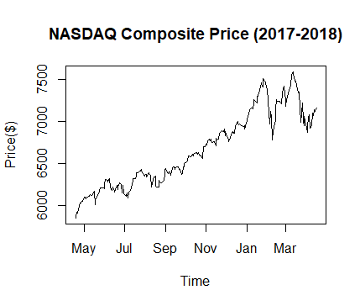

**With respect to the graph above, there is a obvious upward trend in the price movement**

1. Analyze the measures of central tendency calculated and offer opinion on  
   the overall risks and possible rewards associated with investing in the  
   NASDAQ index for the period under study.

**The summary of the returns for the period is given as;**

Min. 1st Qu. Median Mean 3rd Qu. Max.

-3.89706 -0.23101 0.08903 0.08492 0.53146 3.25870

Thus, investing in NASDAQ can yield an averagely daily return of 0.08492%